Match Count
Find the count of occurrences of a word in a given text using regex.
The word to search for is given on the first line.
The text to search in is given on the second line.
Examples
Input | Output
regex  A regular expression, regex or regexp (sometimes called a rational expression) is, in theoretical computer science and formal language theory, a sequence of characters that define a search pattern. | 2
re  A regular expression, regex or regexp (sometimes called a rational expression) is, in theoretical computer science and formal language theory, a sequence of characters that define a search pattern. | 6
Hints
Read the input
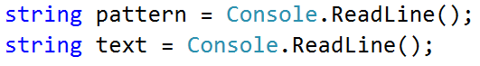
Create Regex object with the provided pattern
Count the occurrences
Finally, print the result
